UNDERSTANDING CYBERSECURITY BASICS AND ATTACK SURFACES

Name: Vaishak M. S
Date: 15 January 2026

1. Introduction to Cyber Resilience
The contemporary digital landscape is characterized by an unprecedented convergence of critical infrastructure, personal data, and financial systems. As global connectivity expands, the complexity of securing these systems grows exponentially. This research explores the foundational pillars of cybersecurity, moving beyond surface-level definitions to examine the deep technical mechanisms that govern data protection.
In this analysis, we dissect the CIA Triad, the taxonomy of Threat Actors, the expanding Attack Surface, and the critical vulnerabilities identified by OWASP. Each section is designed to provide a high-fidelity understanding of how theoretical security models are applied to real-world applications like banking and social media, ensuring that the reader understands not just the "what," but the "how" and "why" behind modern cyber defense.

2. The CIA Triad: Deep Application-Level Archetypes
The CIA Triad (Confidentiality, Integrity, and Availability) serves as the industrystandard benchmark for evaluating security postures. In a research-oriented context, these are not just goals but measurable metrics defined by cryptographic primitives and operational redundancies.
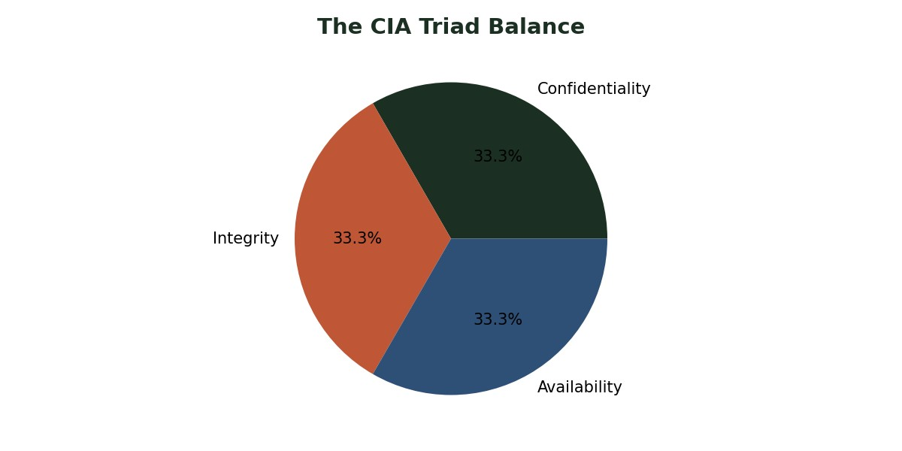
Figure 1: The Equilibrium of the CIA Triad in Information Systems

2.1 Confidentiality
Confidentiality ensures that sensitive information is accessible only to authorized entities. This is maintained through Asymmetric Encryption (RSA, ECC) for key exchange and Symmetric Encryption (AES-256) for data persistence.
Banking Application: In retail banking, confidentiality extends beyond simple login credentials. It involves the obfuscation of Personally Identifiable Information (PII) and the use of Hardware Security Modules (HSMs) to manage PINs and cryptographic keys. Fraud scenarios often involve the bypass of Multi-Factor Authentication (MFA) via session hijacking or SIM swapping, where the confidentiality of the session token is compromised.
Social Media: For platforms like WhatsApp or Instagram, confidentiality is enforced via End-to-End Encryption (E2EE) using the Signal Protocol. Research into metadata leaks shows that even if content is confidential, communication patterns (who talked to whom and when) remain a significant privacy risk.

2.2 Integrity
Integrity guarantees that data has not been altered in an unauthorized manner during transit or at rest. This is mathematically validated using Cryptographic Hash Functions (SHA-256, SHA-3) and Digital Signatures.
Banking Application: Consider Transaction Tampering. If an attacker intercepts a packet and changes the recipient's IBAN, the integrity is lost. Modern banking uses Message Authentication Codes (MACs) and Blockchain-based Ledgers to prevent Balance Manipulation. Every transaction must be atomic and immutable.
Social Media: Integrity protects against "Information Operations." Attackers may attempt to inject fake posts into a user’s feed or manipulate content markers to spread misinformation. Ensuring that a digital asset (photo/video) matches its original hash is critical for authenticity in the era of deepfakes.

2.3 Availability
Availability ensures that systems and data are accessible to users when needed. This is measured by SLA (Service Level Agreement) percentages (e.g., 99.999%).
Banking: Outages in banking (caused by DDoS or database locks) can freeze national economies. High availability is achieved through Geo-Redundancy and Load Balancers. Ransomware is the ultimate threat to availability, as it encrypts the master file table, rendering data inaccessible.
Social Media: While not "critical infrastructure" in a legal sense, social media downtime results in massive lost revenue for businesses relying on social commerce and ad-spend.

3. Taxonomy of Threat Actors
Understanding the adversary is fundamental to threat modeling. Threat actors are categorized by their Intent, Capability, and Resource Availability.
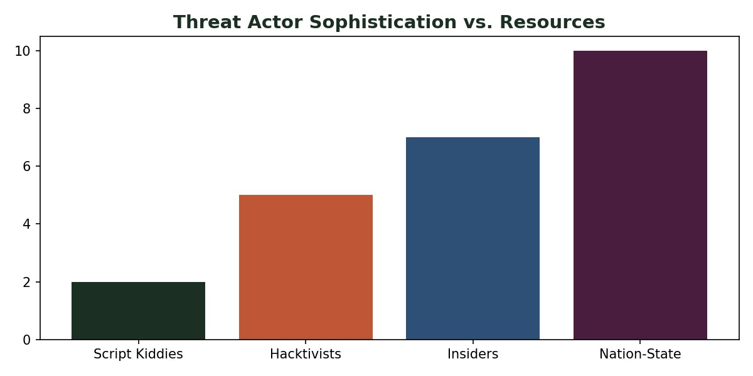
Figure 2: Sophistication vs. Motivation Matrix for Threat Actors

3.1 Script Kiddies
These are unsophisticated individuals who use pre-existing automated tools and scripts found on the dark web or GitHub (e.g., Metasploit, LOIC) to launch attacks. Their primary goal is often notoriety or "bragging rights" rather than financial gain. Despite their lack of technical depth, they represent a significant volume of noise on networks, often performing Credential Stuffing or basic SQL Injection scans.

3.2 Insider Threats
The Insider Threat is often the most dangerous because they operate within the "trust boundary." They have legitimate access to internal systems, knowledge of the network topology, and understand the organization's business logic. Insiders may be Malicious (stealing IP), Coerced (blackmailed by external actors), or Negligent (misconfiguring a cloud storage bucket).

3.3 Hacktivists
Hacktivists are driven by ideology, social justice, or political change. Groups like Anonymous utilize Website Defacement, Doxing, and Leaks of sensitive correspondence to embarrass their targets. Their technical capability varies from moderate to high, often utilizing crowd-sourced botnets.

3.4 Nation-State Actors
Nation-state actors are the pinnacle of cyber threats. They possess unlimited funding, advanced research labs, and exploit Zero-Day Vulnerabilities. Their operations are characterized by Persistence (APT) and Stealth. They target critical infrastructure (power grids, water systems) and perform long-term intellectual property theft.

4. Deconstructing the Attack Surface
The Attack Surface refers to the sum total of all points where an unauthorized user can try to enter data to or extract data from an environment. Minimizing the attack surface is a core principle of Zero Trust Architecture.
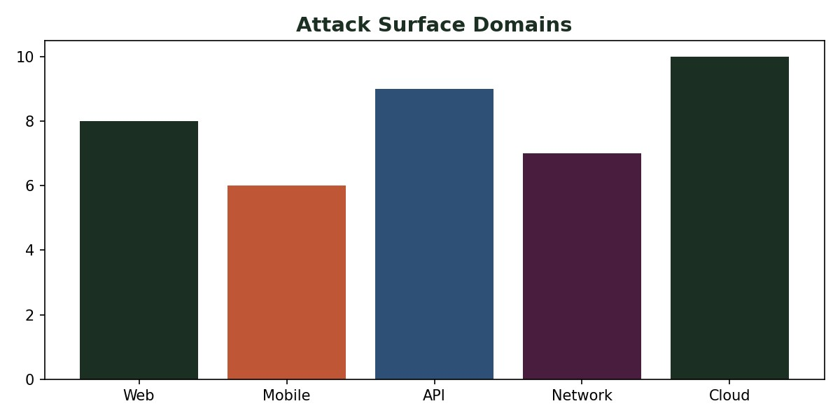
Figure 3: Multi-Dimensional Breakdown of Modern Attack Surfaces

4.1 Web and Mobile Applications
Web applications expose logic via HTTP/HTTPS. Attackers target the Document Object Model (DOM) or server-side rendering engines. Mobile apps increase the surface by introducing Local Storage risks, insecure Inter-Process Communication (IPC), and weaknesses in biometric authentication implementations.

4.2 APIs and Microservices
In the era of "Headless" applications, APIs (REST, GraphQL) represent the largest machine-to-machine attack surface. Vulnerabilities like BOLA (Broken Object Level Authorization) allow attackers to access data by simply guessing a resource ID in a URL.

4.3 Network and Cloud Infrastructure
Traditional network boundaries have dissolved. The attack surface now includes Cloud Control Planes (AWS IAM, Azure AD misconfigurations), Edge Computing nodes, and Virtual Private Clouds (VPC). A single misconfigured S3 bucket can expose millions of records.

5. OWASP Top 10: Deep Technical Analysis
The OWASP Top 10 is the definitive list of global application security risks.
Understanding these requires a deep dive into how computers process instructions and data.

5.1 Injection (SQLi, Command, LDAP)
Why Dangerous: Injection happens when untrusted data is sent to an interpreter as part of a command. An attacker can manipulate the Abstract Syntax Tree (AST) of a query, allowing them to bypass logins or dump entire databases. Example: 1' OR '1'='1.

5.2 Broken Authentication
Why Dangerous: This permits attackers to compromise passwords, keys, or session tokens to assume other users' identities. It often involves weak Session Management where session IDs are predictable or not rotated after login.

5.3 Sensitive Data Exposure
Why Dangerous: This is a failure to protect data at rest and in transit. Lack of Perfect Forward Secrecy (PFS) or using outdated protocols like TLS 1.0 allows attackers to decrypt traffic later if they obtain the server's private key.

5.4 XML External Entities (XXE)
Why Dangerous: Poorly configured XML parsers can be used to read internal files, perform internal port scans, or launch DDoS attacks. It exploits the DTD (Document Type Definition) processing capabilities of XML engines.

5.5 Broken Access Control
Why Dangerous: This occurs when users can act outside of their intended permissions. A common example is Insecure Direct Object References (IDOR), where changing a 'user_id' in a URL provides access to another user's profile.

5.6 Security Misconfiguration
Why Dangerous: This is the most common vulnerability. It includes leaving default credentials, open S3 buckets, or detailed error messages that reveal Stack Traces to attackers, assisting their exploitation efforts.

5.7 Cross-Site Scripting (XSS)
Why Dangerous: XSS allows attackers to execute malicious scripts in a victim's browser. This can steal Session Cookies, redirect the user, or capture keystrokes. It bypasses the Same-Origin Policy (SOP).

5.8 Insecure Deserialization
Why Dangerous: When an application takes user-supplied serialized objects and converts them back into memory, an attacker can craft objects that execute code upon reconstruction. This frequently leads to Remote Code Execution (RCE).

5.9 Using Components with Known Vulnerabilities
Why Dangerous: Modern software is built on thousands of open-source libraries. If a single dependency (like Log4j) has a flaw, the entire application stack is compromised. This is also called a Software Supply Chain Attack.

5.10 Insufficient Logging and Monitoring
Why Dangerous: Without logs, an intrusion may go undetected for months. Most major breaches are discovered by third parties rather than the victim organization because of inadequate SIEM (Security Information and Event Management) integration.

5.11 Server-Side Request Forgery (SSRF)
Why Dangerous: SSRF allows an attacker to force the server to make requests to internal resources that are otherwise protected by firewalls. This is particularly lethal in Cloud Environments where metadata services can be queried for credentials.

6. Daily-Used Applications and Their Unique Vectors
Our daily lives are integrated with applications that create massive, high-value attack surfaces.

6.1 Email (SMTP/IMAP)
Email remains the primary vector for Business Email Compromise (BEC). Attackers target the human element through Phishing, but technically, they exploit lack of DMARC/ SPF/DKIM records to spoof sender identities.

6.2 WhatsApp/Messaging
While the content is encrypted, attackers target the Endpoint Secure Element. If the phone is compromised by spyware (like Pegasus), the encryption is bypassed because the message is read after decryption on the device. Attackers also target Backup Vaults in the cloud (iCloud/Google Drive) which may not be encrypted with the same rigor.

6.3 Banking Apps
Banking apps are targeted by Overlay Attacks. Malicious Android apps can draw a fake login screen over the real banking app to capture credentials. Furthermore, banking APIs are scanned for Logic Flaws—errors in how transactions are processed (e.g., sending a negative amount to 'gain' money).

7. The Data Flow Paradigm and Attack Mapping
To understand where security fails, one must visualize the movement of data from the client to the persistence layer. Each transition between layers represents a Trust Boundary.
[
USER / CLIENT ] ---(1)---> [ WEB/MOBILE APP ] ---(2)---> [ SERVER
]
| | |
| | |
(Social Eng) (XSS/Auth) (RCE/LFI)

7.1 Transition Analysis
- (1) User Input: Where validated parameters are expected. Attackers inject payloads (XSS, SQLi strings) here.
- (2) Application Logic: The server-side code (Node.js, Python, Java). Vulnerabilities like Auth Bypass or Insecure Deserialization happen during the processing of requests.
- (3) Server to Database: The Data Access Layer. If queries are not parameterized, SQL Injection occurs here, leading to mass data exfiltration.

8. Strategic Mapping: Where Attacks Happen
Attacks do not happen in isolation; they target specific layers of the technology stack.
Layer | Primary Attack  Type | Technical Mechanism
Client Side | XSS / CSRF | Browser script execution and session theft.
Network | DDoS / MitM | Protocol exhaustion and packet sniffing.
Application | Auth Bypass / RCE | Exploiting logic errors and memory corruption.
Database | SQL Injection | Manipulation of the DB query language.

9. Conclusion and Final Summary
The security of modern digital systems is not a binary state but a continuous process of risk management. By applying the CIA Triad, we establish a baseline for defense. Recognizing the diverse range of Threat Actors allows us to build targeted threat models. Understanding the Attack Surface ensures we minimize our exposure, while the OWASP Top 10 provides a roadmap for mitigating the most pervasive technical vulnerabilities.
As we have seen in the mapping of Daily-Used Applications and Data Flows, every interaction with technology carries inherent risk. A research-oriented approach to security demands that we constantly evaluate the integrity of our trust boundaries and the robustness of our cryptographic controls. Future resilience depends on Defense in Depth—where multiple layers of security are orchestrated to fail safely, ensuring that even if one layer is breached, the core data remains protected.
Final Synthesis:
- CIA Triad: The blueprint for security goals.
- Threat Actors: The variable adversaries we defend against.
- Attack Surface: The landscape of engagement.
- OWASP: The checklist of technical pitfalls.
- Data Flow: The path of potential exploitation.
END OF RESEARCH REPORT

